MLR

Multiple Linear Regression is Simple Linear Regression, but with more Relationships

1 independent variable with multiple dependent variables

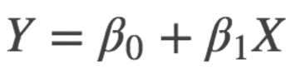 è Linear

Y = B0 + B1 X1 + B2 X2 + B3 X3 ... è Multiple

relationship between one continuous dependent variable (y) and two or more independent variables (x1, x2, x3… etc).

CONTINUOUS dependent variables è y will be a value instead of a 1 or 0 answer categorical / Log Reg

Categorical Variables è Continuous Variables
change categorical variables into continuous
Continuous variables running numbers.
Categorical variables are categories.

Phone num
044 12345678
011 12345678
011 23456789
022 98765432
022 76543218
0452 89076533
0451 87654321

categorical variables appear continuous at first.
Categorical Variables are also referred to as discrete or qualitative variables. There are 3 types:
Nominal: more than 2 types. e.g., color
Dichotomous: 2 types e.g., yes or no
Ordinal: more than 2 types but have a rank/order e.g., Below average, Average, Above Average

Dichotomous Variables
The simple solution for dichotomous variables would be to change it into binary — “1” means “yes” and “0” means “no” or vice versa. Your label should start at 0. BINARY

Nominal Variables
Let’s say you have 3 different colors: Red, Blue and Grey. Following the concept above, you label Red as 0, Blue as 1 and Grey as 2. ENUM
RED 0
BLUE 1
GREY 2

Ordinal Variables TRUTH TABLE
OCC
RED 16 0 1
BLUE 20 0 0
GREY 14 1 0
50

“Ranking” with labels would work better for Ordinal variables, since they do have a rank and should be given different weightage.
When facing nominal variables that should not have different weightage, one hot encoding is preferred.

One Hot Encoding
Give categories è unequal values
Create dummy variables è Create more x.
Fake/dummy variables è placeholders for actual variable
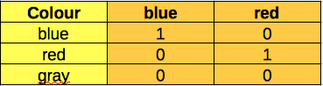

Gray = Reference Category
Which variable you choose to as a reference category? Use the category that happens most often

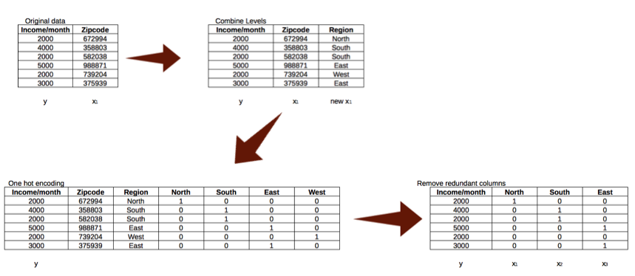

So instead of 500 different zip codes, you get 4 regions, North, South, East or West

if new data comes in where you need to predict the outcome, you can predict the y based on which area the new zip code falls

when encoding ordinal variables (categorical variables with rank), you must ensure that the rank value corresponds to the actual significance of each rank

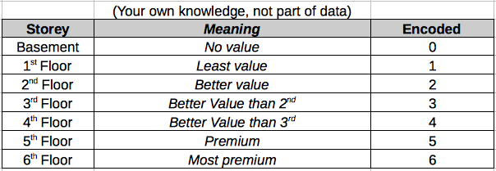

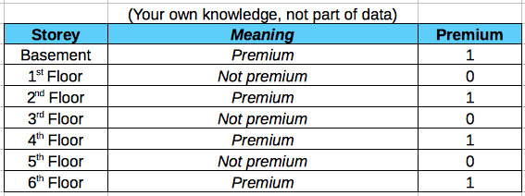

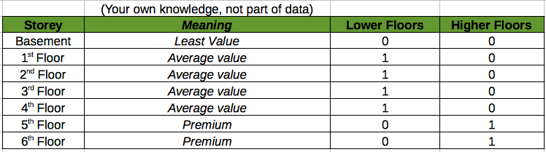

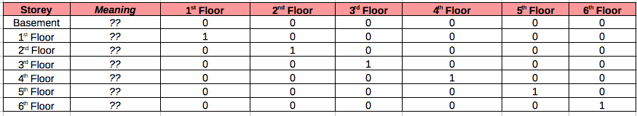

Feature Selection

Having too many variables could potentially cause your model to become less accurate, especially if certain variables have no effect on the outcome or have a significant effect on other variables.

select features is to use the p-values probability - values è how statistically significant the variable is.
variables with high p-values can cause your accuracy
omitting variables is part of stepwise regression.
3 ways
Forward Selection: Start with 0. Run the model over and over, trying each variable. Find the variable that gives the best metric. Run model again with the chosen variable, trying one of the remaining variables at each time and sticking with the best one. Repeat process until the adding does not improve the model anymore.
Backward Elimination: Start with all variables. Multiple times è excluding one variable at each time.
Remove variable that causes the model to improve the most when it is left out. Repeat process without the removed variable, until the metric(s) can no longer improve.
Bidirectional Elimination: Do a forward selection, but then do backward eliminations as well

Correlation and Collinearity
Checking for collinearity è get rid of variables è no significant relationship with another variable.
Correlation between variables describe the relationship between two variables. If they are extremely correlated, then they are collinear.

Autocorrelation occurs when a variable’s data affects another instance of that same variable (same column, different row).
Linear regression only works if there is little or no autocorrelation in the dataset, and each instance is independent of each other.

Multicollinearity exists when two or more of the predictors (x variables) in a regression model are moderately or highly correlated (different column).

the regression equation is the best fit line to represent the effects of your predictors and the dependent variable, and does not include the effects of one predictor on another.

Having high collinearity (correlation of 1.00) between predictors will affect your coefficients and the accuracy, plus its ability to reduce the SSE (sum of squared errors

Multiple Regression - Example
I run a company and I want to know how my employees’ job performance relates to their IQ, their motivation and the amount of social support they receive. Intuitively, I assume that higher IQ, motivation and social support are associated with better job performance. The figure below visualizes this model.

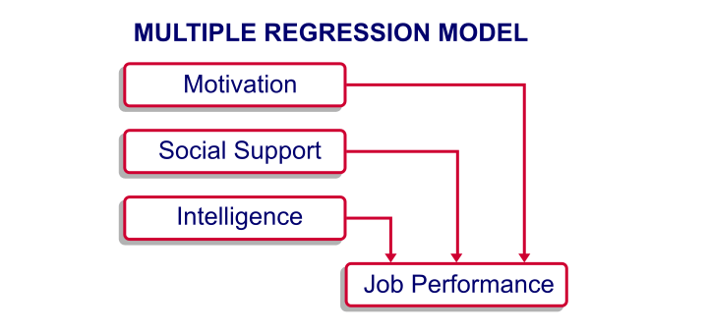
In order to use regression analysis, we need data on the four variables (1 criterion and 3 predictors) in our model.

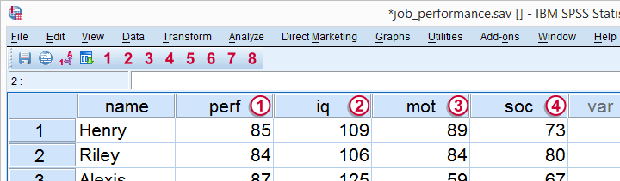

Multiple Regression - Meaning Data
The meaning of each variable in our data

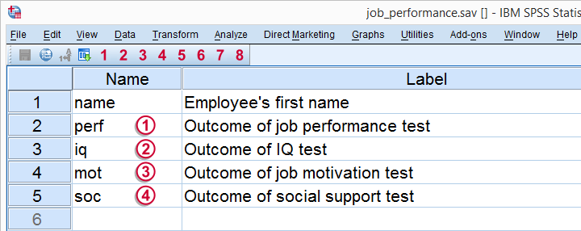

Regarding the scores on these tests, tests , and have scores ranging from 0 (as low as possible) through 100 (as high as possible).
IQ has an average of 100 points with a standard deviation of 15 points in an average population; roughly, we describe a score of 70 as very low, 100 as normal and 130 as very high.

=========================

import numpy as np
import matplotlib.pyplot as plt
'''
for style in plt.style.available:
print(style)

'''

# Fixing random state for reproducibility
np.random.seed(19680801)

def plot_scatter(ax, prng, nb_samples=100):
"""Scatter plot.
"""
for mu, sigma, marker in [(-.5, 0.75, 'o'), (0.75, 1., 's')]:
x, y = prng.normal(loc=mu, scale=sigma, size=(2, nb_samples))
ax.plot(x, y, ls='none', marker=marker)
ax.set_xlabel('X-label')
ax.set_title('Axes title')
return ax

def plot_colored_sinusoidal_lines(ax):
"""Plot sinusoidal lines with colors following the style color cycle.
"""
L = 2 * np.pi
x = np.linspace(0, L)
nb_colors = len(plt.rcParams['axes.prop_cycle'])
shift = np.linspace(0, L, nb_colors, endpoint=False)
for s in shift:
ax.plot(x, np.sin(x + s), '-')
ax.set_xlim([x[0], x[-1]])
return ax

def plot_bar_graphs(ax, prng, min_value=5, max_value=25, nb_samples=5):
"""Plot two bar graphs side by side, with letters as x-tick labels.
"""
x = np.arange(nb_samples)
ya, yb = prng.randint(min_value, max_value, size=(2, nb_samples))
width = 0.25
ax.bar(x, ya, width)
ax.bar(x + width, yb, width, color='C2')
ax.set_xticks(x + width)
ax.set_xticklabels(['a', 'b', 'c', 'd', 'e'])
return ax

def plot_colored_circles(ax, prng, nb_samples=15):
"""Plot circle patches.

NB: draws a fixed amount of samples, rather than using the length of
the color cycle, because different styles may have different numbers
of colors.
"""
for sty_dict, j in zip(plt.rcParams['axes.prop_cycle'], range(nb_samples)):
ax.add_patch(plt.Circle(prng.normal(scale=3, size=2),
radius=1.0, color=sty_dict['color']))
# Force the limits to be the same across the styles (because different
# styles may have different numbers of available colors).
ax.set_xlim([-4, 8])
ax.set_ylim([-5, 6])
ax.set_aspect('equal', adjustable='box') # to plot circles as circles
return ax

def plot_image_and_patch(ax, prng, size=(20, 20)):
"""Plot an image with random values and superimpose a circular patch.
"""
values = prng.random_sample(size=size)
ax.imshow(values, interpolation='none')
c = plt.Circle((5, 5), radius=5, label='patch')
ax.add_patch(c)
# Remove ticks
ax.set_xticks([])
ax.set_yticks([])

def plot_histograms(ax, prng, nb_samples=10000):
"""Plot 4 histograms and a text annotation.
"""
params = ((10, 10), (4, 12), (50, 12), (6, 55))
for a, b in params:
values = prng.beta(a, b, size=nb_samples)
ax.hist(values, histtype="stepfilled", bins=30,
alpha=0.8, density=True)
# Add a small annotation.
ax.annotate('Annotation', xy=(0.25, 4.25),
xytext=(0.9, 0.9), textcoords=ax.transAxes,
va="top", ha="right",
bbox=dict(boxstyle="round", alpha=0.2),
arrowprops=dict(
arrowstyle="->",
connectionstyle="angle,angleA=-95,angleB=35,rad=10"),
)
return ax

def plot_figure(style_label=""):
"""Setup and plot the demonstration figure with a given style.
"""
# Use a dedicated RandomState instance to draw the same "random" values
# across the different figures.
prng = np.random.RandomState(96917002)

# Tweak the figure size to be better suited for a row of numerous plots:
# double the width and halve the height. NB: use relative changes because
# some styles may have a figure size different from the default one.
(fig_width, fig_height) = plt.rcParams['figure.figsize']
fig_size = [fig_width * 2, fig_height / 2]

fig, axs = plt.subplots(ncols=6, nrows=1, num=style_label,
figsize=fig_size, squeeze=True)
axs[0].set_ylabel(style_label)

plot_scatter(axs[0], prng)
plot_image_and_patch(axs[1], prng)
plot_bar_graphs(axs[2], prng)
plot_colored_circles(axs[3], prng)
plot_colored_sinusoidal_lines(axs[4])
plot_histograms(axs[5], prng)

fig.tight_layout()

return fig

if __name__ == "__main__":

# Setup a list of all available styles, in alphabetical order but
# the `default` and `classic` ones, which will be forced resp. in
# first and second position.
style_list = ['default', 'classic'] + sorted(
style for style in plt.style.available if style != 'classic')

# Plot a demonstration figure for every available style sheet.
for style_label in style_list:
with plt.style.context(style_label):
fig = plot_figure(style_label=style_label)

plt.show()

